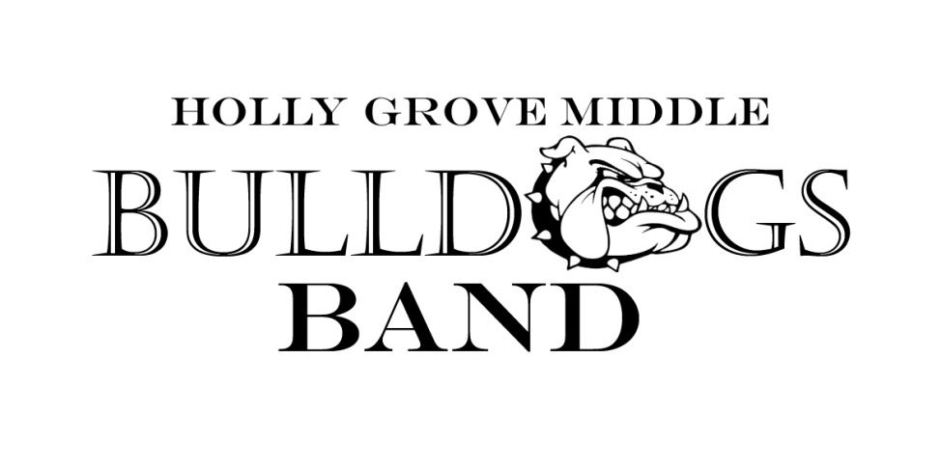

2015-16 Calendar

Below are the performance/audition dates for the 2015-16 school year. More information will be sent home regarding each event as it becomes available. Please check the band calendar for more up to date information on each performance (www.hollygrovebands.com)

Fall Semester

July 16 Instrument Rental Meeting
- Tracks 1, 2 and 3 6th grade students

July 21 and 23 Jazz Band Auditions
- 6th, 7th and 8th grade students

August 6 Instrument Rental Meeting
- Track 4 6th grade students

September TBA HSHS Middle School Band Night
- Open to all 8th grade students

September TBA MCHS Middle School Band Night
- Open to all 8th grade students

October TBA Pep Band Performance at HGMS Football Game
- Select 7th and 8th grade students

October 2 FVHS Middle School Band Night
- Open to all 8th grade students

October 20 All-County Auditions
- Select 7th and 8th grade students

November 5, 6 All-County Clinic
- Select 7th and 8th grade students

December 3 Holly Grove Band Concert
- All tracks, all grades

December 15 Performing Arts Hollipalooza
- Jazz Band Members

Spring Semester

January 9 All-District Auditions
- Select 7th and 8th grade students

January 29-30 All-District Clinic
- Select 7th and 8th grade students

March TBA Pre-MPA Performance
- 8th Grade Band

March TBA All-State Auditions
- Select qualifying students

March 14-16 MPA (Band EOG)
- 8th grade to perform 1 of 3 days

April 19 Performing Arts Spring Performance
- Jazz Band Members

April 20-25 Fine Arts Disney Trip
- Jazz Band Members

May TBA All State Clinic
- Select qualifying students

May 5 Holly Grove Band Concert
- All tracks, all grades

May 27 HGES Memorial Day Celebration
- 7th and 8th grade bands

May TBA Track 1 8th Grade Graduation
- 7th grade band

June TBA Tracks 2, 3 and 4 8th Grade Graduation
- 7th grade band

