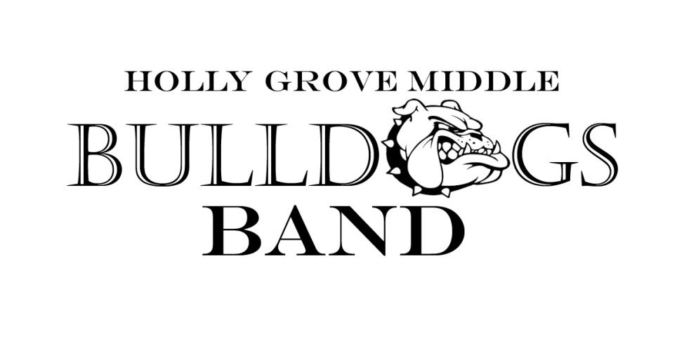

2017-18 Calendar

Below are the performance/audition dates for the 2017-18 school year. More information will be sent home regarding each event as it becomes available. Please check the band calendar for more up to date information on each performance (www.hollygrovebands.com)

Fall Semester

July 20 Instrument Rental Meeting
- Tracks 1, 2 and 3 6th grade students

July 25 and 27 Jazz Band Auditions
- 6th, 7th and 8th grade students

August 10 Instrument Rental Meeting
- Track 4 6th grade students

September 22 HSHS Middle School Band Night
- Open to all 7th and 8th grade students

October 6 MCHS Middle School Band Night
- Open to all 8th grade students

October 19 Pep Band Performance at HGMS Football Game
- Open to all 7th and 8th grade students

October 20 FVHS Middle School Band Night
- Open to all 8th grade students

October 24 All-County Auditions
- Select 7th and 8th grade students

November 2 Pep Band Performance at HGMS Football Game
- Open to all 7th and 8th grade students

November 16, 17 All-County Clinic
- Select 7th and 8th grade students

November 30 Holly Grove Band Concert
- All tracks, all grades

December 5 Annual All Arts Grinch Performance
- Jazz Band Members

Spring Semester

January 6 CDBA All-District Auditions
- Select 7th and 8th grade students

January 26, 27 CDBA All-District Clinic
- Select 7th and 8th grade students

March TBA Pre-MPA Performance
- 8th Grade Band

March 3 All-State Auditions
- Select qualifying students

March 19-20 CDBA East Middle School MPA (Band EOG)
- MPA Band to perform 1 of 2 days (Mandatory for all 4 tracks)

April 17 Performing Arts Spring Performance
- Jazz Band Members

April 18-23 Performing Arts Disney Trip
- Jazz Band Members

May TBA All State Clinic
- Select qualifying students

May 10 Holly Grove Band Concert
- All tracks, all grades

May 25 HGES Memorial Day Celebration
- 7th and 8th grade bands

May TBA Track 1 8th Grade Graduation
- 7th grade band (All Tracks)

June TBA Tracks 2, 3 and 4 8th Grade Graduation
- 7th grade band (All Tracks)

