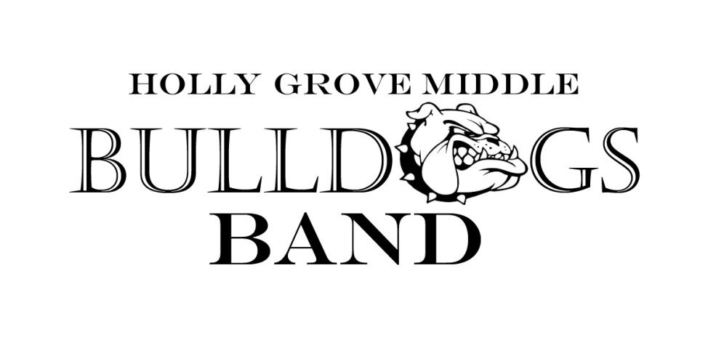

2018-19 Calendar

Below are the performance/audition dates for the 2018-19 school year. More information will be sent home regarding each event as it becomes available. Please check the band calendar for more up to date information on each performance (www.hollygrovebands.com)

Fall Semester

July 17 Instrument Rental Meeting
- Tracks 1, 2 and 3 6th grade students

July 24 and 26 Jazz Band Auditions
- 6th, 7th and 8th grade students

August 9 Instrument Rental Meeting
- Track 4 6th grade students

September 14 HSHS Middle School Band Night
- Open to all 7th and 8th grade students

October TBA MCHS Middle School Band Night
- Open to all 8th grade students

October 11 Pep Band Performance at HGMS Football Game
- Open to all 7th and 8th grade students

October TBA FVHS Middle School Band Night
- Open to all 8th grade students

October 23 All-County Auditions
- Open to all 7th and 8th grade students

November 8 Pep Band Performance at HGMS Football Game
- Open to all 7th and 8th grade students

November 15, 16 All-County Clinic
- Select 7th and 8th grade students

December 6 Holly Grove Band Concert
- All tracks, all grades

December 11 Annual All Arts Grinch Performance
- Jazz Band Members

Spring Semester

January 5 CDBA All-District Auditions
- Open to all 7th and 8th grade students

January 25, 26 CDBA All-District Clinic
- Select 7th and 8th grade students

March 8 Pre-MPA Performance
- MPA Band

March 2 All-State Auditions
- Select qualifying students

March 18-19 CDBA East Middle School MPA (Band EOG)
- MPA Band to perform 1 of 2 days (Mandatory for all 4 tracks)

April 9 Performing Arts Spring Performance
- Jazz Band Members

April 10-15 Performing Arts NYC Trip
- Open to 7th and 8th grade students, Jazz Band Members

May 3-5 All State Clinic
- Select qualifying students

May 9 Holly Grove Band Concert
- All tracks, all grades

May 24 HGES Memorial Day Celebration
- 7th and 8th grade bands

May TBA Track 1 8th Grade Graduation
- 7th grade band (All Tracks)

June TBA Tracks 2, 3 and 4 8th Grade Graduation
- 7th grade band (All Tracks)

